Data Collection

Questions for a member of staff
- What is your role, and how are you involved in activity/problem? (How are you involved in assessing students’ contributions to group work?)
- Template, disadvantages and advantages, what should be changed?
- Where do delays, mistakes or difficulties happen? Can you give an example?
- What features would you like to see in a new system?
- What information do you need to complete the process, and how is it recorded?
(information to judge a student contribution on, e.g. GitHub contributions, written proof, what kind of evidence)
- Who can create, view, update or approve that information? (review, add remove members etc)
- Should students be allowed to edit their contributions?
- What rules, deadlines or exceptions does the process need to handle? (dispute, deadlines etc)
(How would you judge whether the new system was successful?)
- Should different contribution types have different weight towards the overall group mark? Or are all contributions calculated equally
- Is there features you specifically wouldn’t want in the system?

- Permissions – Should teachers have access to the dashboards, or groups editing permissions, is there something they should not see

Questions for a student
- How do you currently assess individual contributions to group projects? (how often, what form, etc)
- template
- (Were there any barriers to completing it—for example, access, device compatibility or unclear instructions?)
- What would a new system need to let you do for it to be useful? (How would you want to log your contributions, choose teams, deal with disputes)
- What would make a dispute feel "fair" to you? Would you want the rest of the team to vote, or would you rather have a teacher look at it and decide? At what point should a lecturer get involved in a dispute?
- Should you be able to edit or delete a contribution after posting it? If so, should the system keep a record of the original version.
- How would you deal if someone contributed your work as their own? What evidence would you need to provide to prove the work is yours?
- If the disputed contribution is reassessed by a staff member, do you think you should be able to dispute that as well?

Links for the interview questions
Link for Staff:
https://docs.google.com/forms/d/1ut6TmpeSj0VZlOCoJsCYGQn-HQl4LWeo81ytfjj3Z6Q/edit

Link for Student:
https://docs.google.com/forms/d/1QoPhMHg4vowpShn5CQpsxH-6yYJan7c-kkVCUG6WyKI/edit

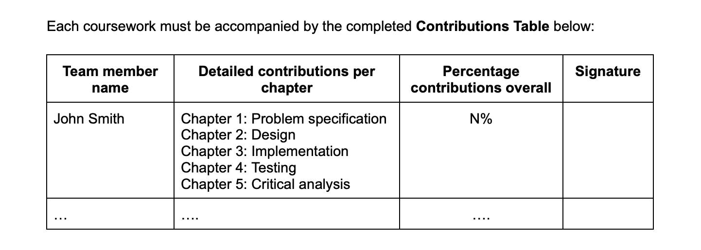
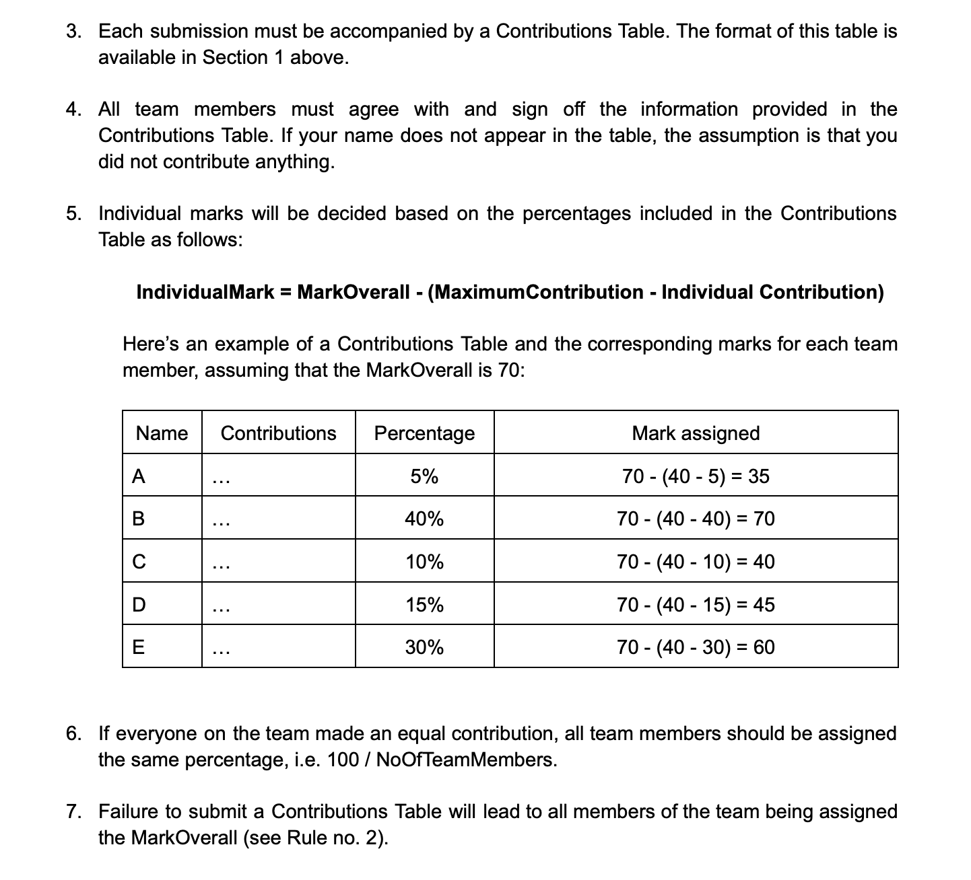
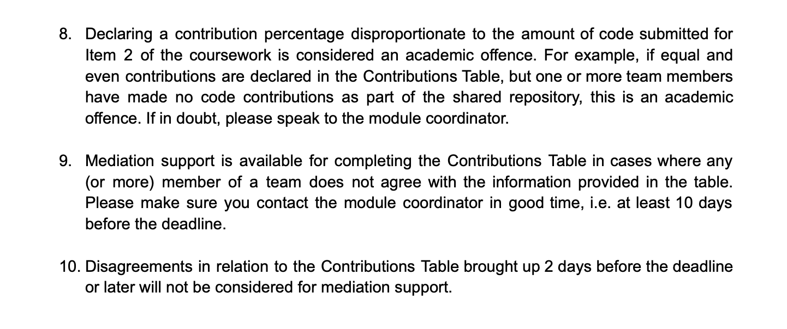
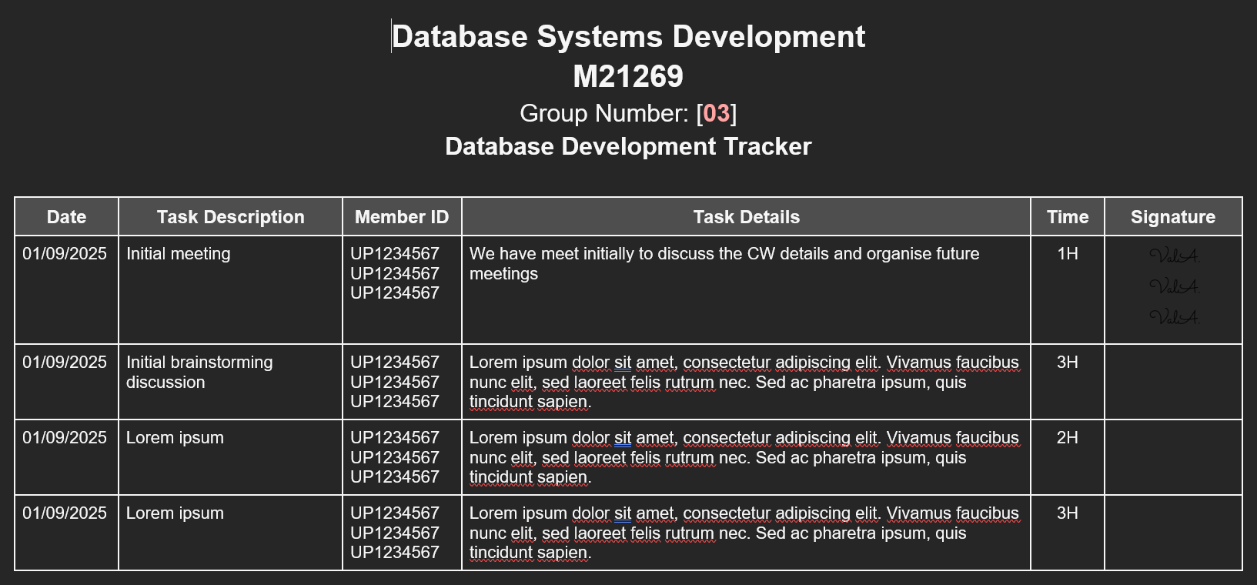

These questions help gather info about:
- Current process – how is staff currently aassessing ccontributions
- Roles – who is involved: students, tutors, should we track team leaders? Should module staff have access
- Current tools that can help – GitHub, Contribution forms, reports, emails, meetings?
- Current problems – Where the current process is slow or inefficient, unfair, unclear, or difficult
- What counts as evidence? -- commits, files, meeting notes, written work?
- Rules – what are deadlines for disputes, do they need course leader or tutor assistance , expectations.
- Dispute process (if exists) -- what steps do students need to take to solve a dispute between the team, if it is escalated or no middle ground met , is the intervention, if so is there penalties?
- Success Criteria – what will makes this system different to other and successful
- Things to avoid -- Features students and tutors do no desire in the system.

